MASH
Whether it is a MANSION, APARTMENT, SHACK or HOUSE come learn how to decorate it in Interior Design!
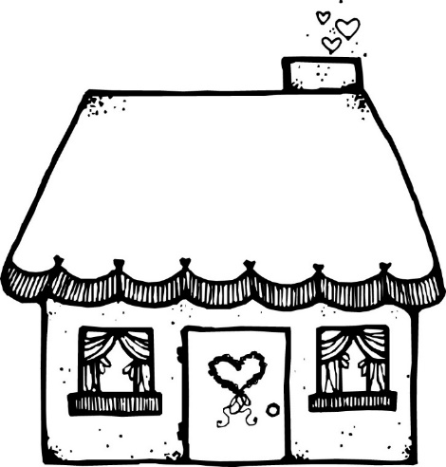

Courses offered:
Interior Design 1, Interior Design 2, INTD 1010

