DO YOU LOVE SPORTS?

IF SO, SIGN UP FOR U.S. SPORTS HISTORY WITH MR. SCHABER!

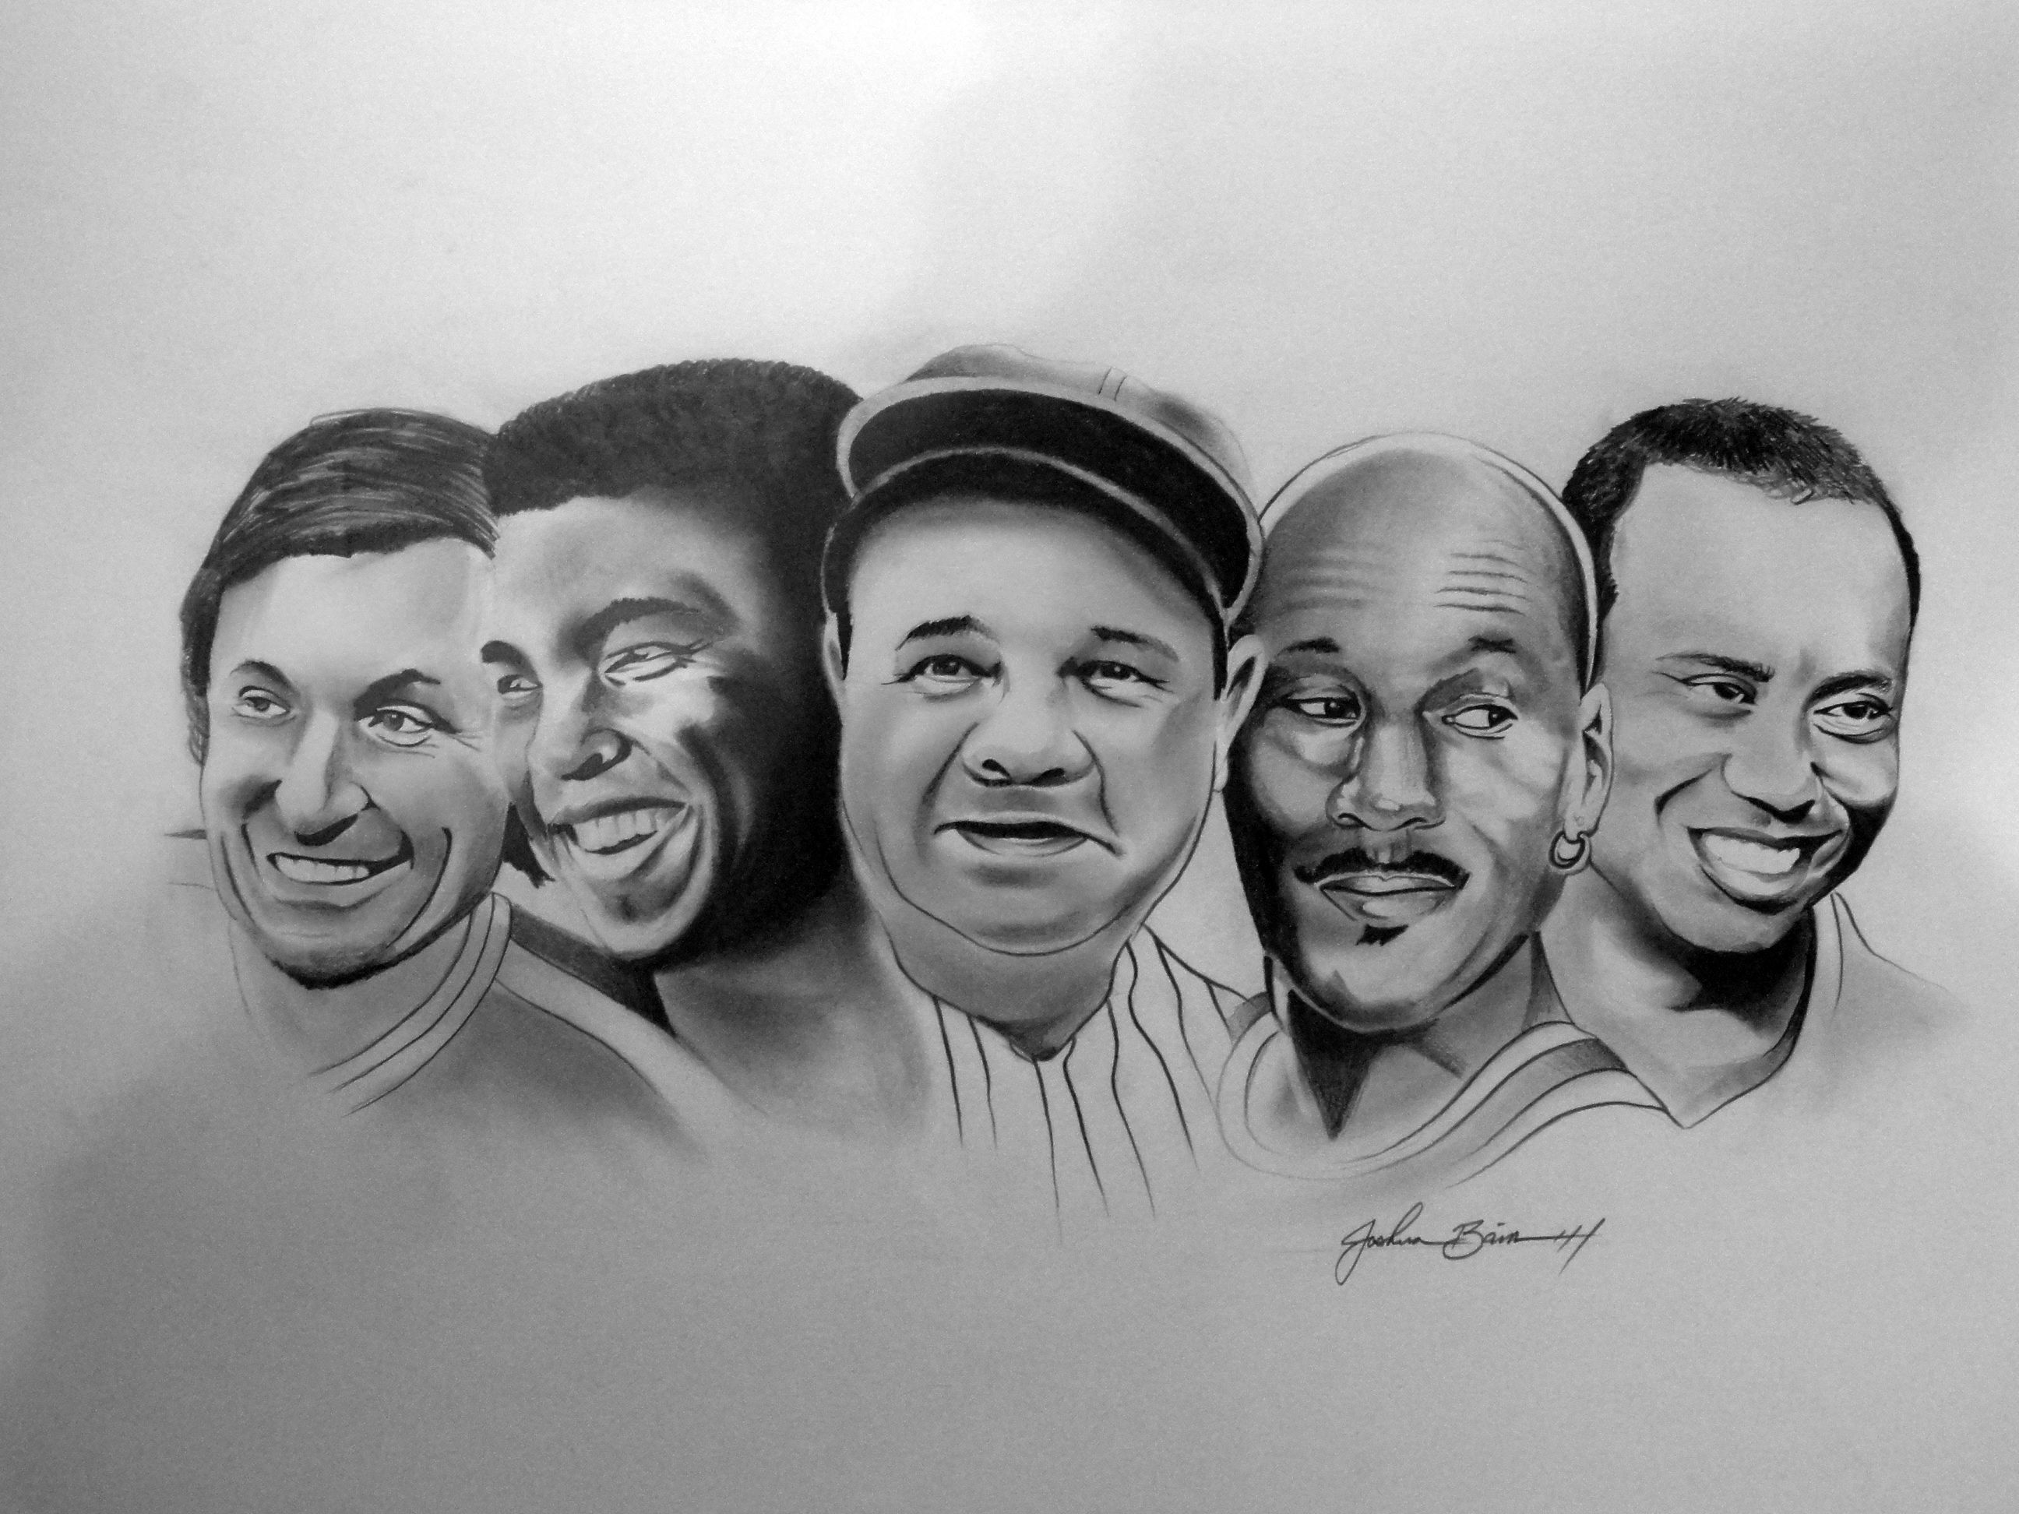

In this 1 Semester class, we cover the history of many sports and their athletes, including Football, Baseball, Basketball, Hockey, Boxing, the Olympics, and more! Come join us!